RINCON OUTFITTERS Booth 841
PROFESSIONAL HUNTING GUIDE SERVICE

860 S. Bay Beach Lane

Tucson, AZ 85748
(520) 349-6497 rincono@hotmail.com
www.rinconoutfitters.com

FALL 2023 / SPRING 2024

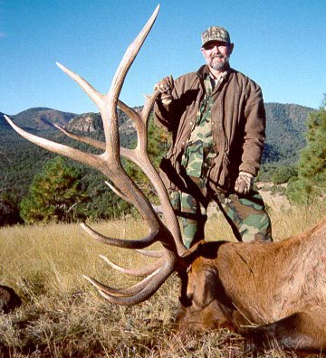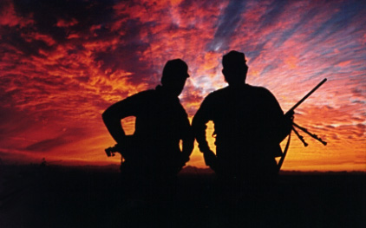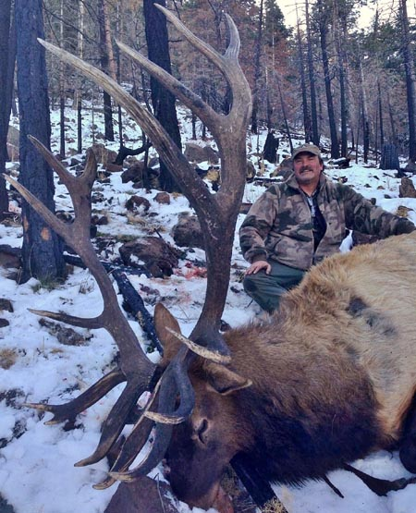

Rincon Outfitters is proud to offer the following guided or outfitted hunts in Arizona and Mexico. Arizona distributes permits through a computerized drawing in March and July with an application date falling in early February for Elk & Antelope, and early June for all other species. Some hunts listed below are available on a “first come/first served” or “over-the-counter” basis and will be denoted accordingly. Please visit us our extensive web-site and photo album at: www.rinconoutfitters.net

TROPHY COUES WHITETAIL
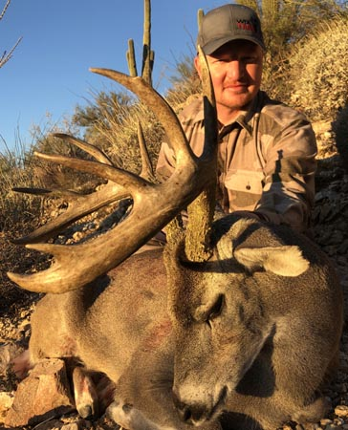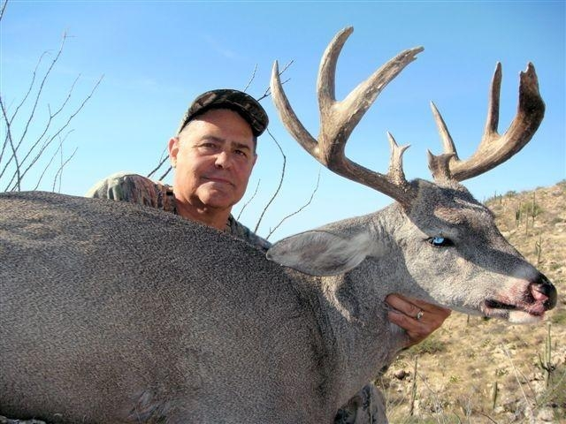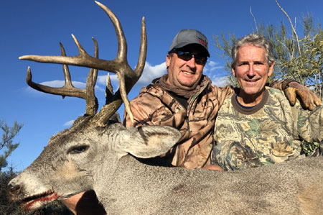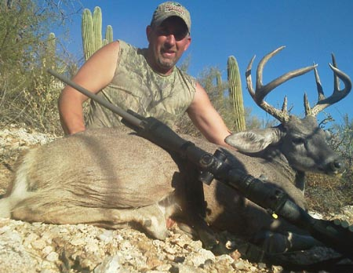

ARIZONA * * RIFLE * MUZZLELOADER * ARCHERY
TROPHY HUNTS IN OCTOBER, NOVEMBER AND DECEMBER
ARCHERY HUNTS IN DECEMBER * JANUARY (CONCURRENT W/ ARCHERY JAVELINA)
Four-day trophy hunts offered in several mountain ranges in Arizona in search of the beautiful and elusive deer commonly known as the “Gray Ghost”. These are our most popular hunts and are guided one on one or two on one from very remote base camps only accessible by 4 x 4 vehicle or by backpack. Draw success for most units is 100%. We have taken numerous outstanding deer on these highly successful hunts with three of our bucks ranking in the Top Ten SCI and dozens of others making the record books. Each year we harvest in excess of forty Coues bucks with many exceeding the 100” mark, and several each year exceeding the B&C minimum of 110”. Why risk hunting in Mexico when our Arizona success exceeds 90% on great Coues. Permits are issued by draw for rifle & muzzleloader hunts and over-the-counter for archery.

$4,500.00 1x1 Arizona (Four Days)/ $3,250 2x1 Arizona (Five Days)

ROCKY MOUNTAIN ELK

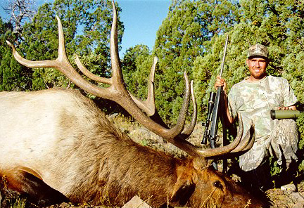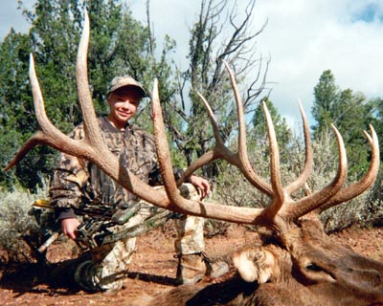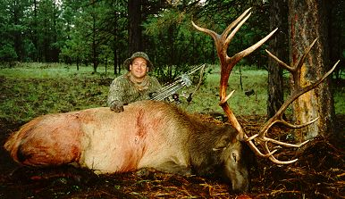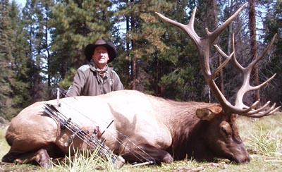

ARIZONA ** RIFLE * ARCHERY * MUZZLELOADER
SEPTEMBER * OCTOBER * NOVEMBER * DECEMBER
ARCHERY & MUZZLELOADER (SEPTEMBER)

Seven-day hunts in the mountains of Northern and Eastern Arizona for the largest Elk in the world. We have taken several outstanding bulls on these hunts in the last few years, including the former Safari Club International #1 Non-Typical Archery bull and two other Top Ten Safari Club bulls. Early hunts with muzzleloader or archery tackle are during the rut and provide the most exciting hunting. These hunts are guided one on one out of wall tent base camps reached by 4 x 4 vehicles. Additional days may be booked at $600.00/day per hunter. These hunts are also offered on a two on one basis at a reduced rate, which may be negotiated at the time of booking. Most permits for these hunts can be difficult to draw depending upon the hunter’s weapon and season of choice. Rincon’s application service is complimentary. Applications are due in early February for Arizona elk.

$6,500.00 One on One

BLACK BEARS “IN THE PEARS”
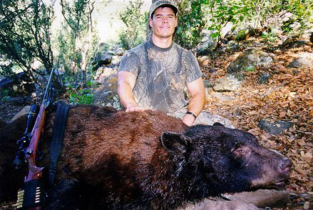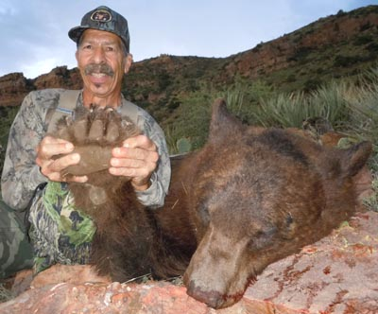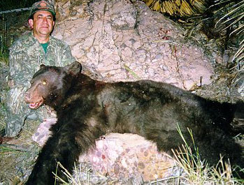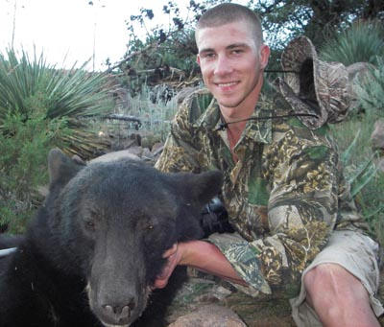

ARIZONA ** RIFLE * ARCHERY * MUZZLELOADER ** AUGUST * SEPTEMBER * OCTOBER

Four-day hunts along the Mogollon Rim of central Arizona and several of southeastern Arizona’s mountain ranges for bears with very large skulls. These hunts are conducted like no other bear hunts in the world in that the bears are hunted in the cactus while they eat the delicious fruit of the prickly pear cactus. On occasion, we have seen in excess of fifteen bears a day during this brief phenomenon of late summer. Our hunting techniques are very similar to our Coues deer hunts with big optics and remote country being the key. If you like exciting hunts, hunting in shorts, and going home with a really nice tan, this is the hunt for you! These permits are available over the counter and our bears are huge, so be sure to book early to ensure your spot in the books!
$3,500.00 1x1(Four Days) / $2,750 2x1 (Five Days)

DESERT MULE DEER
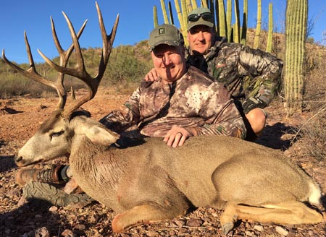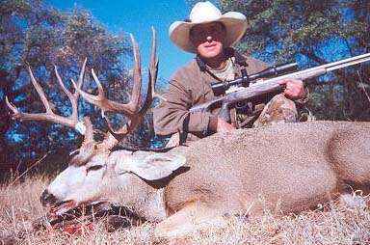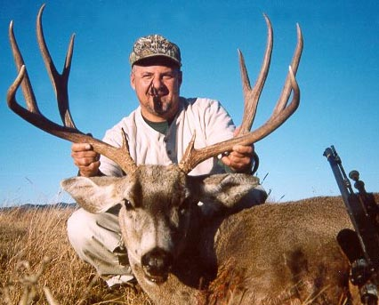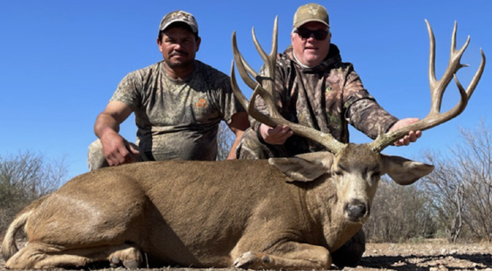

ARIZONA ** RIFLE * MUZZLELOADER * OCTOBER * NOVEMBER * DECEMBER
ARCHERY HUNTS IN AUGUST * SEPTEMBER * DECEMBER * JANUARY
SONORA MEXICO HUNTS IN DECEMBER & JANUARY

Five-day hunts in Southeastern Arizona on public land, private ranches, or National Forest land for this desert dwelling Mule Deer sub-species. These hunts are guided one on one from easily accessed deluxe wall tent base camps. During past seasons, we have harvested seven Top Ten SCI bucks, including the former Muzzleloader Typical World Record (twice) & #3 SCI Muzzleloader Typical and the new World Record, #2 & #3 SCI Muzzleloader Non-Typicals. Rifle and muzzleloader permits are issued by draw only and archery permits are available over-the-counter. Additional days are available at $600.00/day. This hunt is also offered on a two on one basis at reduced rates to be negotiated at time of booking. We highly recommend our muzzleloader hunt for massive desert bucks in a primitive weapons only unit. This unit has not been hunted with modern centerfire rifles since 1978, and the deer are big! If you want a monster desert buck in the United States at an affordable price, this is the hunt for you! If you really want a true monster, our ranches in Mexico deliver!!

$4,500.00 One on One - Arizona
$12,500.00 One on One - Mexico

PRONGHORN ANTELOPE
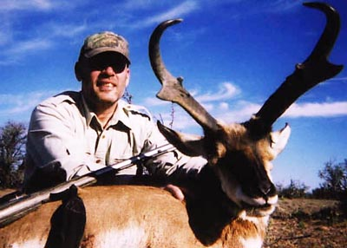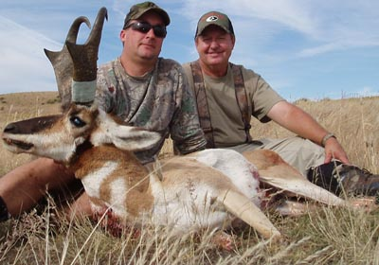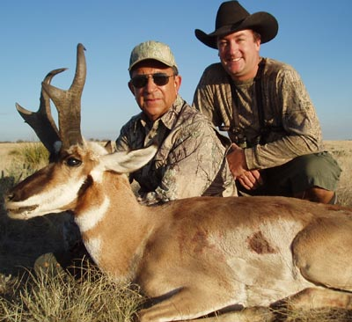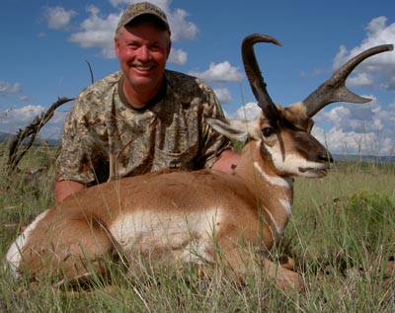

ARIZONA ** RIFLE * MUZZLELOADER ** SEPTEMBER
ARCHERY IN AUGUST * SEPTEMBER
Four-day hunts for animals with magnificent horns in the state that has rewritten the record books. In the past Five seasons, five antelope we have taken qualify for the Boone & Crockett record book (four with muzzleloader), and three of those Antelope went Top Ten SCI as well. Arizona has the largest antelope in the world, but is one of the toughest states in which to draw a rifle permit. Muzzleloader hunts, while still relatively difficult to draw, offer outstanding opportunities at record class goats, and should not be overlooked. These hunts are guided one on one from dome tent base camps or hotels. Additional days are available at $500.00/day/hunter. These hunts are also available on a two on one basis at slightly reduced rates negotiable at time of booking.

$4,000.00 One on One

JAVELINA
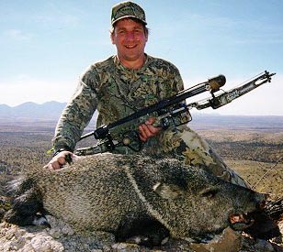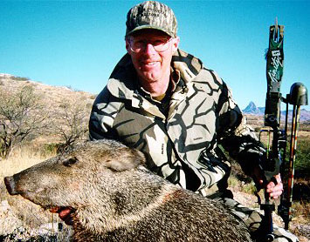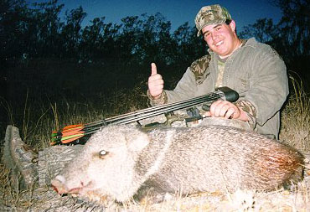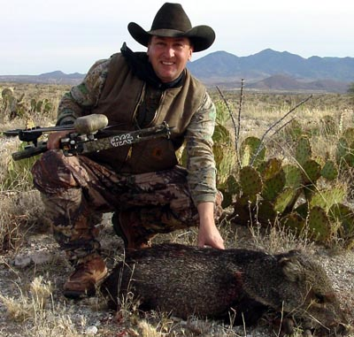

ARIZONA ** RIFLE * MUZZLELOADER * HANDGUN * FEBRUARY
ARCHERY * JANUARY (CONCURRENT WITH ARCHERY DEER)

This minimum two day hunt is one of our favorites. We hunt out of base camps accessible by 4 x 4 vehicles in the mountains and desert floor of southeastern Arizona. The archery hunt in January can be paired with archery Whitetail or Mule Deer (Archery Safari) for a slight additional fee negotiable at time of booking. These hunts are designed for either one on one or two on one and we can accommodate groups of up to eight hunters per camp. Javelina permits are issued by draw only with an October application date; however, some permits are often available first come/first served up until the day of the hunt. Large groups of up to fifteen hunters can be accommodated on an outfitted camp/limited-guiding basis depending upon availability.
$750/day 1X1 $500.00/day 2x1

MERRIAM’S & GOULD’S WILD TURKEY
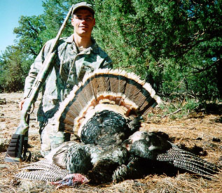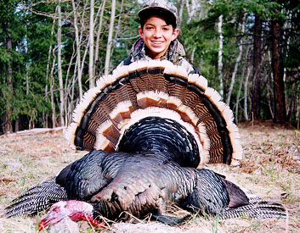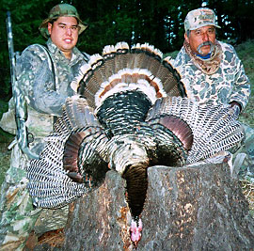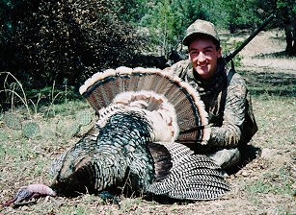

ARIZONA * NEBRASKA * NEW MEXICO * MEXICO ** SHOTGUN * ARCHERY ** SPRING HUNTS ONLY

These minimum three day hunts in Arizona, private ranch land in southwestern New Mexico, the Pine Ridge of Nebraska, and old Mexico (Goulds) occur during the peak of the breeding season in April and May. This hunt pairs the hunter against the gobbler at very close range with excited birds ready for love. All hunting is done by calling only. We will not allow rifle hunting for turkeys on our hunts due to safety reasons. These hunts are conducted from wall or dome tent base camps or ranch house accessed by 4 x 4 vehicles. Permits are by draw in Arizona (October application date) and are over the counter in New Mexico, Nebraska, and old Mexico. A second bird may be harvested in New Mexico or Mexico for a slight additional fee negotiated at time of booking. These hunts are guided one on one, but two on one is available at a reduced rate negotiable at time of booking. Hunters should be in good to excellent condition as some sprinting may be involved in a successful harvest. Note: Hunter education is recommended but not required for Turkey hunting with Rincon Outfitters.

$750.00/day 1x1 $500.00/day 2x1
$3,000.00 (Gould’s/Mexico/2ND BIRD $750)

ARCHERY SAFARI
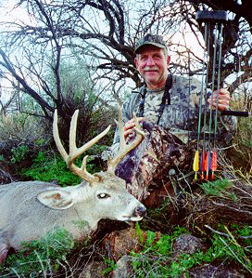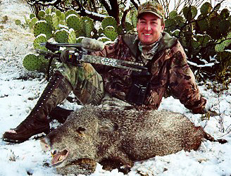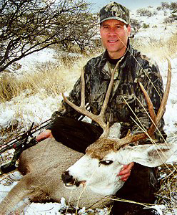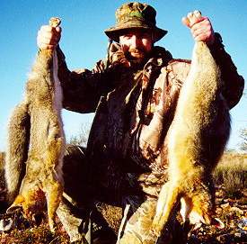

The month of January is the time for our Archery Safari where our hunters hunt for rutting Coues Whitetail and Desert Mule Deer and for the wily Collared Peccary. Along the way, our hunters also harvest unlimited Gray Fox, Coyotes and Bobcats with archery tackle, shotgun or rifle. Waterfowl and Dove are available early in the month and three species of quail are available the entire month long. If you like adventure, lots of shooting, and the beautiful Arizona winter, this is the hunt for you. Archery Deer permits are available over-the-counter and Javelina is by draw (guaranteed). Draw deadline for Javelina is early October, but booking early is recommended, as this hunt is very popular.

$750.00/day 1x1 $500.00/day 2x1

MOUNTAIN LION

ARIZONA***ALL WEAPONS***YEAR LONG SEASON

These rigorous hunts are conducted in northern, eastern and southern Arizona in some of Arizona’s most rugged, but beautiful country. Arizona is well known for our big lions and our guides know how to catch these wily cats. These hunts are conducted from horseback, quad, or vehicle, and we utilize excellent dry ground hounds. These hunts are very successful and permits are available over-the-counter. Please call for dates and availability.

$500/day One on One $3,500 Trophy Fee
$6,500.00 Package Hunt (Five Days)

BIGHORN SHEEP
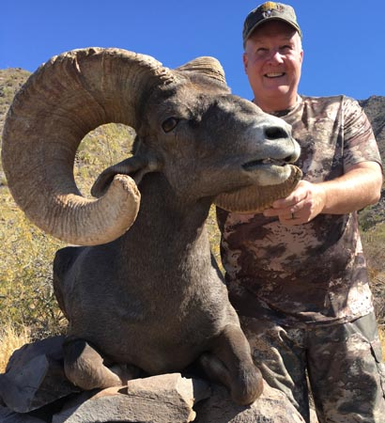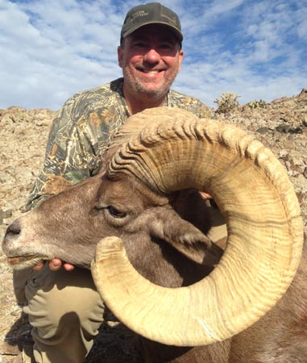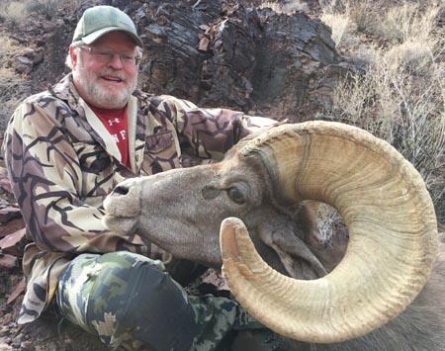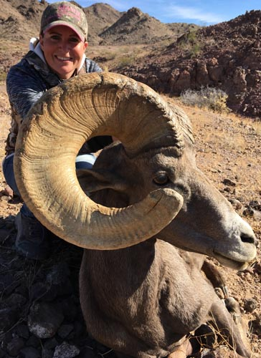
Rincon Outfitters is proud to offer ten-day hunts for the elusive Desert Bighorn or Rocky Mountain Bighorn Sheep. This one on one hunt conducted from tented base camps is a once in a lifetime experience. These permits are allocated by drawing and are extremely difficult to draw. If you are the lucky one, allow Rincon Outfitters to assist you on a hunt you will never forget. Please call for hunt details for our hunts that we also offer in Old Mexico.
$8,500 One on One Arizona
$55,000 Sonora / $37,500 Sonora Estate

BUFFALO
Rincon Outfitters is pleased to announce a limited number of Bull and Cow buffalo hunts on private ranches in New Mexico and South Dakota each year. These private herds offer outstanding opportunities at trophy class animals due to extremely large numbers of animals and these hunts are guaranteed for success. The cape, skull, hide and all the meat belong to the hunter on this very exciting hunt for one of North America’s most dangerous animals. There is no draw for this hunt making this a very desirable offering. Please call for prices and waiting list info.

RINCON OUTFITTERS also offer a variety of other hunts for mearns & desert quail, dove, waterfowl, fox, bobcat and coyote. These hunts will be designed upon request and will be priced at a daily rate. We will be happy to design any other type of hunt that may interest you, or we will refer you to the proper outfitter if we cannot accommodate your request. We are always happy to answer questions about hunting in the west, or to help with other hunting matters which may arise. Our application service for all draw hunts is “No Cost”.

BOOKING INFORMATION
Since we limit the number of spaces each season, we encourage our hunters to book early. Upon receipt of a fifty- percent deposit, the hunt of your choice will be reserved for the dates you desire. The balance is due 30 days before your scheduled arrival in camp. Cancellations 180 days prior to the hunt will result in the deposit being applied to another hunt we offer or a substitute hunter. All other moneys are non-refundable. If booking a hunt at the SCI convention, a deposit of $750 will hold your spot though the draw period, the remaining balance to get to 50% is due upon successful draw, and the balance is due 30 days prior to arrival for your hunt.

ABOUT YOUR OUTFITTERS

Robert “Rom” Dryden is an experienced outdoorsman and licensed professional guide with extensive experience guiding in Arizona and New Mexico. Mr. Dryden is an avid bowhunter and has harvested ninety big game animals with archery tackle, with numerous record book entries for Elk, Antelope, Mule Deer, Whitetail, Turkey, Bear and Javelina. He also occasionally picks up the Muzzleloader or 6.5 PRC for a change of pace. Mr. Dryden is seasoned with optics, long-range rifles, archery equipment, shotguns, muzzleloaders and handguns in various hunting settings. Mr. Dryden has hunted in most western states, Alaska, several mid-western and eastern states, and has also hunted on three safaris on the dark continent of Africa and one safari down under in Australia. Mr. Dryden also gives several informational seminars on various types of hunting in Tucson each year and is a Chief Instructor for the Arizona Game & Fish Dept. hunter education program. He was a board member for ten years and the past President of the Arizona Chapter of Safari Club International, the oldest remaining active chapter of Safari Club International. He is also the former Vice-President of the Southern AZ Chapter of the NWTF. His other affiliations are with the Rocky Mountain Elk Foundation, the Federation for North American Wild Sheep, the North American Hunting Club, the National Wild Turkey Federation, and the Tucson Rod & Gun Club. Mr. Dryden is also a master measurer for Safari Club International.

Rincon Outfitters also employs ten other extremely qualified, licensed, professional hunting guides. These guides are extremely well versed in the preferred hunting techniques of Rincon Outfitters and all the game laws for the state of Arizona. No guides work for Rincon Outfitters until we have spent untold hours in the field with the guides and we are assured of their qualifications. Our guides are the best at what they do, and that is why Rincon Outfitters is so well known for Arizona hunting and Record Class animals.

Please visit our magnificent inter-net site to view our extensive photo album of recent animals harvested. The Internet address is:
www.rinconoutfitters.net

